1. **Experiment:** Hydrogen bond depiction
2. **Time:** 2024.09.30-2024.10.05
3. **Member:** Fan Yang, Qiwen Jiang, Men Sun, Xinxin Zhang, Ziyan Yu
4. **Method:**
5. The PDB file for the protein is prepared.
6. In PyMol, chains should be renamed. Then, hydrogen bonds are found by clicking "find-polar-contacts-to other atoms in object". The stick structures of the protein molecules are displayed. After the amino acids connected by hydrogen bonds are clicked, we show the cartoon figure of the molecules and show the stick structure of the amino acids clicked. Then, the sequence numbers and names of the amino acids can be annotated by clicking on "label-residue".
7. Click "draw/ray-save image to file".
8. **Result:**

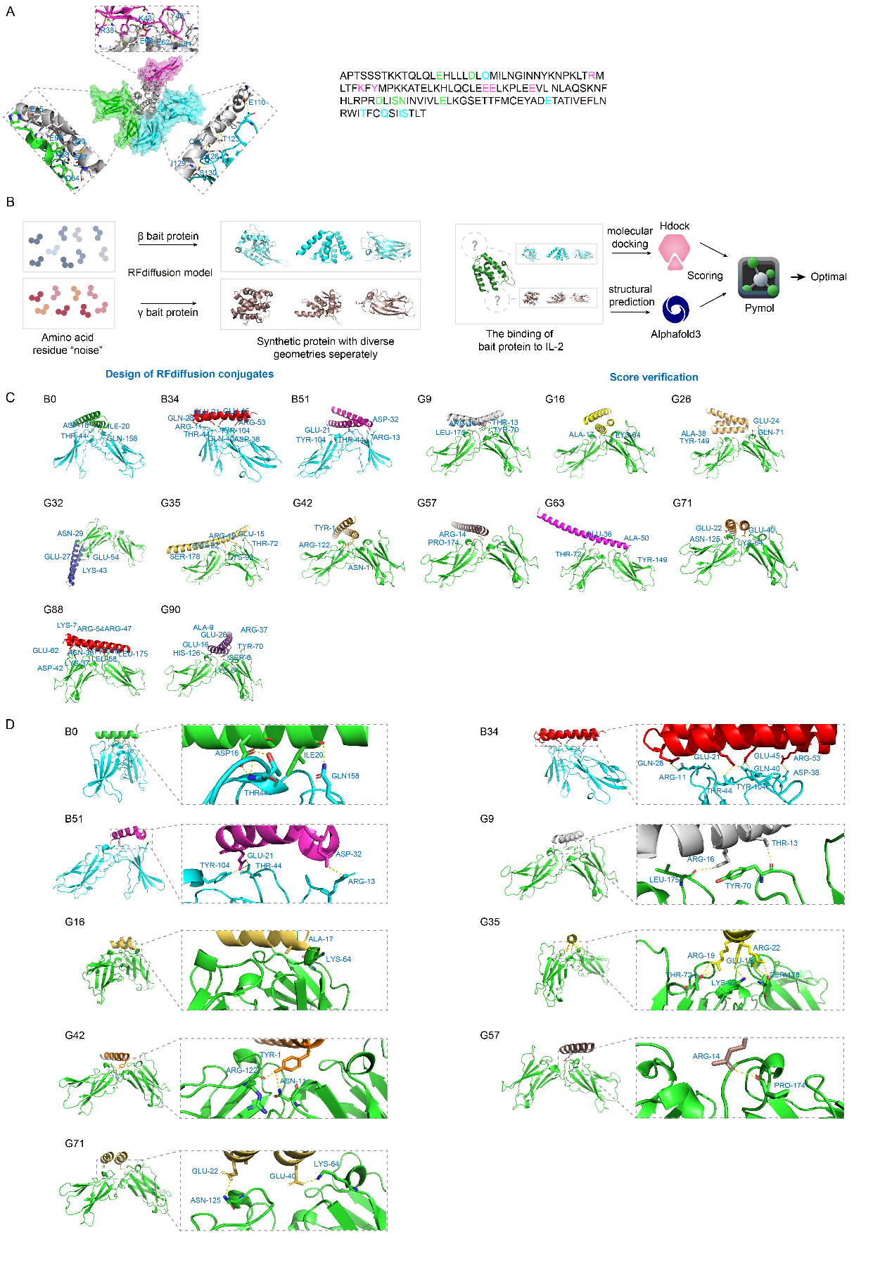

**Fig.1** The front view of the binding sites between screened mimics with IL-2Rβ and γ separately